Abstract
The Career Guidance and Student Support Portal is a mobile application designed to empower students, particularly African youth, in planning and navigating their career journeys. Many students in underserved communities lack access to professional career counseling, mentorship, and educational resources, leaving them ill-equipped to make informed decisions about their futures. This system addresses that gap by providing a comprehensive digital platform that integrates career assessment, personalized roadmaps, mentorship connectivity, learning resources, and scholarship opportunities in one accessible application. The system is aligned with the United Nations Sustainable Development Goal 4 (SDG 4): Quality Education, which advocates for inclusive and equitable quality education and lifelong learning opportunities for all. Developed following the Agile Software Development Life Cycle methodology, the portal features an intuitive user interface designed with inclusivity and usability in mind. This report documents the complete software design process, including system architecture, UML diagram, prototype development, project management planning, and SDG impact assessment.

Introduction
Education is widely recognized as the foundation of personal and national development. However, across many African nations, students face a critical challenge that goes beyond classroom learning they lack access to structured career guidance and support systems. Without proper direction, many talented young people make uniformed academic and career choices, resulting in high dropout rates, unemployment, and underemployment. According to the United Nations, Sub-Saharan Africa has one of the highest youth unemployment rates in the world, a problem deeply connected to the absence of career education and mentorship at the student level.
The rapid growth of mobile technology across Africa presents a unique opportunity to bridge the gap digitally. With smartphone penetration increasing significantly across the continent, a mobile-first approach to career guidance becomes not only viable but highly effective in reaching students where they are.
Problem Statement
Students, especially those in underserved and rural communities, face the following challenges:
Lack of access to qualified career counselors
Limited knowledge of available scholarships, internships, and training opportunities
No structured mentorship from professionals in their fields of interest
Insufficient study materials and learning resources
Inability to track their academic and career progress
These challenges collectively hinder students from making confident, informed decisions about their futures.
Proposed Solution
The career Guidance and Student Support Portal is a mobile application that consolidates career assessment, mentorship, learning resources, opportunity discovery, and progress tracking into a single, easy-to use platform. The app is designed with African students in mind, prioritizing simplicity, offline accessibility, and cultural relevance.

SDG Alignment
This project is directly aligned with SDG 4: Quality Education specifically targets 4.4 and 4.6, which focus on increasing the number of youth with relevant skills for employment and ensuring equal access to affordable and quality education. By democratizing access to career guidance and educational resources, this portal contributes meaningfully to the global education agenda.
Objective of the System
The key objectives of this portal are to:
Provide students with personalized career assessments and roadmaps
Connect students with professional mentors and counselors
Offer a library of downloadable educational resources
Curate scholarship, internship, and training opportunities
Track student progress and motivate continued learning
Demonstrate measurable SDG impact through platform statistics
Scope of the Project
This project covers the complete software design of the Career Guidance and Student Support Portal, including the SDLC plan, system architecture, UML diagrams, Figma prototype, GitHub repository setup, project management plan, and full documentation. The target users are secondary and tertiary students, particularly across African communities.

Literature Review
This section examines existing research, systems, and frameworks relevant to the Career Guidance and Student Support Portal. It explores the concept of Digital Public Goods, the global state of career guidance, existing similar platforms, Software Development Life Cycle models, and the United Nations Sustainable Development Goal 4. The review identifies gaps in current solutions that this system aims to address.
Digital Public Goods (DPGs)
The concept of Digital Public Goods was formally defined by the United Nations Secretary-General’s Roadmap for Digital Cooperation (2020), which described DPGs as open-source software, open data, open AI models, open standard, and open content that adhere to privacy and other applicable laws and best practices, do no harm, and help attain the Sustainable Development Goals. The Digital Public Goods Alliance (DPGA) further established a standard requiring that a system must be relevant to the SDGs, use an approved open license, and demonstrate no harmful impact on individuals or communities to qualify as a DPG.
The Career Guidance and Student Support Portal aligns with this definition. It is designed as an open, accessible platform targeting SDG 4, built to serve public interest rather than private profit, particularly benefiting students in underserved communities who would otherwise have no access to structured career support.
The State of Career Guidance in Africa
Career guidance in African educational institutions remains largely underdeveloped. A report by the African Union Commission (2016) on the Continental Education Strategy for Africa highlighted that most secondary schools across the continent lack dedicated career counselors, and where they exist, the ratio of counselor to student is alarmingly high sometimes one counselor serving over a thousand students. Thing makes meaningful, personalized career guidance practically impossible through traditional means. Research by Hooley, Marriott, and Sampson (2011) established that access to career guidance significantly improves student outcomes, including higher rates of employment, better academic performance, and improved decision-making around further education. The absence of such guidance in African schools therefore represents a serious developmental gap with long-term economic consequences.
Furthermore, studies have shown that African youth are increasingly turning to mobile technology for information and education. The GSMA Mobile Economy Sub-Saharan Africa report (2023) noted that mobile internet penetration in Sub-Saharan Africa reached 28% with continued growth projected. This makes mobile applications a highly effective channel for delivering career guidance and educational support to young people across the continent.
Existing Career Guidance Systems and Platforms
Several digital career guidance platforms exist globally, each offering varying degrees of functionality. A review of these systems helps identify both best practices and existing gaps.
LinkedIn is one of the world’s largest professional networking platforms, offering career exploration, job listings, and professional connections. However, it is primarily designed for working professionals and university graduates, making it largely inaccessible and irrelevant to secondary school students or first-year undergraduates in Africa who are still on the early stages of career exploration.
Morrisby is a UK-based career guidance platform that offers psychometric assessments and career matching tools for students. While effective, it is a paid service that is largely unavailable and unaffordable in Africa markets.
Career Portal (South Africa) is a local platform offering career information, subject choices guidance, and bursary listings for South African students. It provides useful content but lacks interactive mentorship features, progress tracking, and personalized career roadmaps.
Kuder is a globally recognized career assessment and planning platform used in many schools. It offers interest assessments, career exploration tools, and educational planning resources. However, it is subscription-based, primarily designed for western educational systems, and does not cater to the African curriculum or context.

Platform | Career  Assessment | Mentorship | Local Scholarships | Mobile-First | Free Access | African Context
LinkedIn | No | Limited | No | Partial | No | No
Morrisby | Yes | No | No | No | No | No
Careers Portal | Partial | No | Yes (SA only) | No | No | No
Kuder | Yes | No | No | No | No | No
Our Portal | Yes | Yes | Yes | Yes | Yes | Yes

This comparison clearly demonstrates that no existing platform comprehensively address the needs of African students in a mobile-first, free, and contextually relevant manner. The Career Guidance and Student Support portal fills this gap.
Career Assessment Theory
The career assessment component of this system is grounded in established career development theories. Holland’s Theory of Career choice (1959) proposes that individuals can be categorized into six personality types, Realistic, Investigative, Artistic, Social, Enterprising, and Conventional (RIASEC) and that matching a person’s type to a compatible career environment leads to greater satisfaction and success. This theory forms the conceptual backbone of the career assessment feature in the portal, where students answer questions about their interests, strengths, and subject preferences to receive personalized career recommendations.
Additionally, Super’s Life-Span, Life-Space Theory (1980) emphasizes that career development is a lifelong process that evolves through different life stages. This reinforces the need for a system that supports students not just at a single point in time but continuously through progress tracking, milestone setting, and ongoing mentorship.

The Role of Mentorship in Student Development
Research consistently shows that mentorship plays a critical role in student academic and career success. A study by Eby et al. (2008) found that students who had access to mentors demonstrated higher levels of academic achievement, career clarity, and personal confidence compared to those without mentorship support. In the African context, where formal career counseling is scarce, peer and professional mentorship becomes even more vital.
The mentorship module of this portal bridges students with lecturers, counselors, engineers, and other professionals, creating a structured digital mentorship environment that would otherwise be inaccessible to most African students.
SDG 4: Quality Education
The United Nations Sustainable Development Goal 4 calls for inclusive and equitable quality education and the promotion of lifelong learning opportunities for all by 2030. Its specific targets most relevant to this project include:
Target 4.4: by 2030. Substantially increase the number of youth and adults who have relevant skills, including technical and vocational skills, for employment, decent jobs, and entrepreneurship.
Target 4.5: By 2030, eliminate gender disparities in education and ensure equal access to all levels of education and vocational training for the vulnerable.
Target 4.6: Ensure that all youth and a substantial proportion of adults achieve literacy and numeracy.
Summary of Literature Review
The literature establishes a clear and urgent need for a mobile-based, freely accessible, and contextually relevant career guidance system for African students. Existing platforms fail to serve this demographic adequately due to cost barriers, lack of African context, absence of mentorship features, and limited mobile optimization. Career development theories such as Holland’s RAISEC model and Super’s life-Span Theory provide a strong academic foundation for the system’s career assessment module. The alignment with SDG 4 further validates the social and developmental relevance of this project.

Methodology
This section describes the software development approach adopted for the Career Guidance and Student Support Portal. It outlines the chosen Software Development Life Cycle (SDLC) model, justifies its selection, and explains in detail how each phase of the model was applied to the development of this system.
Chosen SDLC Model: Agile Development
The Agile Software Development Life Cycle was selected as the methodology for this project. Agile is an iterative and incremental approach to software development that emphasizes flexibility, collaboration, continuous feedback, and the delivery of working software in short cycles called sprints.
Justification for Choosing Agile
Flexibility: The requirements of a student-facing mobile application can evolve based on user feedback. Agile allows features to be developed and tested in stages, meaning core features like career assessment and mentorship could be built and reviewed before moving to additional features.
User-Centered: Agile places strong
User-Centered: Agile places strong emphasis on involving end users throughout the process, which is critical for a system targeting students from diverse backgrounds.
Risk Management: By delivering and testing in short sprints, risks are identified and resolved early rather than discovered at the end of development.
Suitable for Mobile App Development: Agile is widely recognized as the most effective methodology for mobile application development due to its adaptability and focus on continuous improvement.
Agile SDLC Phases Applied to This System
Phase 1: Planning
In this phase, the overall vision, objectives, and scope of the Career Guidance and Student Portal were defined. The key activities carried out during planning included identifying the target users, defining the core problem the system features, estimating the project timeline, setting up the GitHub repository, and selecting tools and technologies including Figma and GitHub.
Phase 2: Requirements Analysis
During this phase, both functional and non-functional requirements of the system were gathered and documented.
Functional Requirements:
Users must be able to register, log in, and recover their passwords
The system must provide a career assessment based on subjects, interests, and strengths
The system must generate personalized career recommendations with roadmaps and salary information
Students must be able to browse and download learning resources including past papers, study guides, and video tutorials
Students must be able to browse mentor profiles and initiate chat conversations
The system must display available scholarships, internships, and training opportunities
Students must be able to track their progress through milestones
The system must display SDG impact statistics
Non-Functional Requirements:
The application must be mobile-first and responsive
The system must be easy to navigate for users with limited digital literacy
The application must support offline access for downloaded resources
The system must load efficiently even on low-bandwidth connections
The system must ensure user data privacy and security
Phase 3: System Design
In this phase, the architectural and visual design of the system was developed. Activities including designing the overall system architecture, creating UML diagrams including use Case, Class, and Activity Diagrams, designing the user interface using Figma (15 high-fidelity screen), and defining the database schema.
Phase 4: Prototype Development
Following the design phase, a working high-fidelity prototype of the system was developed using Figma. The prototype covers fifteen key screens spanning all major application features from onboarding through to the SDG impact Dashboard.
Phase 5: Testing
Testing was conducted continuously throughout the development process including usability testing, functional testing, consistency testing, peer review, and feedback integration into revised prototype versions.
Phase 6: Review and Iteration
After each sprint, work completed was reviewed against project requirements and feedback used to refine the system. Iterations included revising screen layouts, adding career roadmap detail, improving mentor profile screens, and refining the SDG impact Dashboard.
Phase 7: Deployment Planning
The planned deployment strategy includes publishing the mobile application on the Google Play Store and Apple App Store, hosting the backend on Firebase or AWS, conducting a pilot launch at selected schools in Sierra Leone, and scaling the platform progressively across other African nations.
Agile Sprint Plan Summary
Sprint | Focus Area | Duration
Sprint 1 | Planning, Requirements Gathering, GitHub Setup | Week 1 – Week 2
Sprint 2 | System Architecture Design & UML Diagrams | Week 3 – Week 4
Sprint 3 | UI/UX Design Onboarding & Career Assessment Screens | Week 5 – Week 6
Sprint 4 | UI/UX Design Learning, Mentorship & Opportunities Screens | Week 6 – Week7
Sprint 5 | UI/UX Design Profile, Progress & SDG Impact Screens | Week 7 – Week 8
Sprint 6 | Testing, Review & Iteration | Week 9 – Week 10
Sprint 7 | Documentation, Finalization & Submission | Week 10 – Week 11

Summary of Methodology
The Agile SDLC provided a structured yet flexible framework for the design and development of the Career Guidance and Student Support Portal. By working in iterative sprints, the project was able to progressively build and refine each component of the system while remaining responsive to feedback and evolving requirements.

System Architecture Design
This section presents the architectural design of the Career Guidance and Student Support Portal. It describes the overall structure of the system, identifies the key components that make up the platform, explains how those components interact with one another, and presents the UML diagrams that model the system’s behavior and structure.
Architectural Style
The Career Guidance and Student Support Portal follows a Three-Tier Client-Server Architecture, which divides the system into three distinct layers:
Presentation Layer (Frontend) the mobile application interface that users interact with directly
Application Layer (Backend) the server-side logic that processes requests, manages business rules, and coordinates data flow
Data Layer (Database) the storage system that holds all application data including user profiles, career assessments, resources, mentor information, and opportunities.
Description of Architecture Component
Presentation Layer (Mobile Application)
The presentation layer is the mobile application that students interact with directly. It is built as a cross-platform mobile application compatible with both Android and iOS devices. The key modules include: Onboarding & Authentication, Career Assessment, Learning Resources, Mentor Connect, Opportunities, progress Tracker, and SDG Impact Dashboard.
Application Layer (Backend Server)
The application layer server as the brain of the system. It processes all requests from the mobile application, applies business logic, and communicate with the database through a RESTful API over HTTPS. Key services include: Authentication service, Career Engine (using RAISEC matching logic), Resource Manager, Mentor service, Opportunity service, and Notification service.
Data Layer (Cloud Database)
The data layer is responsible for the persistent storage of all system data hosted on a cloud platform. It maintains the following databases: Users, Careers, Resources, Mentors, Opportunities, and Progress Tracker.
External Services
The system integrates with firebase Authentication for secure user login, Firebase storage / AWS S3 for large file hosting, and Firebase Cloud Messaging (FCM) for push notifications.
How Component Interact
The interaction between components follows a clear request-response flow:
The student opens the mobile app and the Presentation Layer renders the appropriate screen
When the student registers or logs in, credentials are sent to the Authentication Service via a secure API call
The Authentication Service validates credentials against the Users Database and returns an authentication token
When taking a career assessment, answers are sent to Career Engine which applies RIASEC logic and queries the Careers Database
Recommendations are returned to the Presentation Layer as personalized career roadmaps
When browsing resources, the Resource Manager retrieves metadata and provides download links from cloud storage
When connecting with a mentor, the Mentor Service retrieve profiles and facilitates real-time chat
The Notification Service monitors deadlines and triggers push notifications via Firebase Cloud Messaging
The SDG impact Dashboard aggregates data from multiple databases to display real-time statistics

UML Diagram
Use Case Diagram
The Use Case Diagram identifies three actors: Student (primary user), Mentor (professional; guide), and System Administrator (platform manager).
Key Use Cases for Student:
Register / Login
Take Career Assessment
View Career Recommendations
Browse and Download Learning Resources
Browse Mentor Profiles
Chat with Mentor
View Scholarships and Opportunities
Apply for Opportunity
Track Progress
View SDG Impact Dashboard
Receive Notifications
Key Use Cases for Mentor
Register / Login
Set Up Profile
Respond to Student Messages
Update Availability
Key Use Cases for Administrator:
Manage User Accounts
Upload Learning Resources
Add/Update Opportunities
Monitor Platform Statistics

Class Diagram
The Class Diagram models the key entities in the system and their relationships. Key classes include: User (base class with userID, name, email, password, role), Student (extends User, adds profession, expertise, availability), CareerAssessment, CareerRoadmap, LearningResource, mentorChat, Opportunity, and ProgressTracker.
Key Relationships:
A student can complete many CareerAssessments
A CareerAssessment generates one CareerRoadmap
A student can access many LearningResources
A student can chat with many Mentors through MentorChat
A student can apply for many Opportunities
A student has one ProgressTracker
Activity Diagram Career Assessment Flow
The Career Assessment flow begins when the student opens the assessment screen. The system displays questions about subjects, interests, and strengths. The student submits answer which are processed by the Career Engine using RIASEC matching. The system queries the Career Database, generates personalized recommendations, and displays the career roadmap to the student, who may then download or save it.
Mentor Connection Flow
The Mentor Connection flow begins when the student opens the mentor Browse screen. The system displays available mentors which the student can filter by profession or expertise. The student selects a mentor, views their profile, and clicks Connect. The system creates chat session, the student sends a message, the mentor receives a notification, responds, and the student receives a reply notification.

Technology Stack
Component | Technology
Mobile Frontend | React Native (cross-platform)
Backend Server | Node.js with Epress.js
Database | Firebase Firestore (NoSQL)
Authentication | Firebase Authentication
File Storage | Firebase Storage
Push Notifications | Firebase Cloud Messaging (FCM)
UI/UX Design | Figma
Version Control | GitHub
API Communication | RESTful API over HTTPS

Summary of System Architecture
The Career Guidance and Student Support Portal is built on a robust Three-Tier Client-Server Architecture that cleanly separates the presentation, application, and data layers. The system’s modular design ensures that each feature operates as an independent service while communicating seamlessly through a secure RESTful API. The UML diagrams provide a comprehensive visual model of the system’s structure, actors, behaviors, and data flows.

Prototype Development
This section documents the prototype developed for the Career Guidance and Student Support Portal. The prototype was created using Figma, a professional UI/UX design tool, and represents a high-fidelity visual model of the final mobile application. A high-fidelity prototype closely resembles the look, feel, and interaction of a fully developed application, making it can effective tool for communicating design decisions, gathering feedback, and validating user experience before actual development begins.
Design Principles
Simplicity: Screens are clean and uncluttered, ensuring students with limited digital experience can navigate easily
Consistency: Uniform use of colors, typography, button styles, and icons across all screens creates a cohesive visual experience
Accessibility: Large readable fonts, high contrast colors, and clearly labeled buttons ensure the app is usable by students across different literacy levels
Mobile-First: All screens are designed specifically for mobile devices, optimizing layout, touch targets, and navigation for smaller screens
Cultural Relevance: The visual design reflects an African student context, using relatable imagery, inclusive language, and locally relevant content examples
Design System
Element | Specification
Primary Color | Deep Blue (#1A3C6E)
Secondary Color | Vibrant Orange (#F4821F)
Background color | Light Grey (#F5F5F5)
Text color | Dark Charcoal (#2D2D2D)
Success Color | Green (#27AE60)
Front Family | Poppins (Modern, readable, widely supported)
Heading Size | 24px Bold
Baby Text Size | 14px Regular
Button Style | Rounded corners, full width, primary color fill
Icon Style | Outlined, consistent stroke weight
Corner Radius | 12px for cards, 8px for buttons

Prototype Screens
Screen 1: Splash Screen
The splash screen is the first screen users see when they open the application. It displays the application logo, name, and tagline centered on a deep blue background. A subtle loading animation plays while the app initializes. This screen creates the first impression of the platform and establishes the brand identity.
Screen 2: Onboarding slides
The onboarding section consists of three slides that introduce new users to the key features of the application. Each slide contains an illustration, a bold heading, and a brief description. Navigation dots at the bottom indicate progress through the slides. The three slides cover Career Discovery, Mentorship Access, and Opportunity Finder.
Screen 3: Registration Screen
The registration screen allows new users to create an account. It contains input fields for full name, email address, school or university name, password, and confirm password. A Register button submits the form. Input validation is applied to ensure all fields are correctly completed before submission.
Screen 4: login Screen
The login screen provides returning users with access to their accounts. It contains fields for email address and password, a Forget Password link, and a Login button. A secondary option allows users to sign in with Google through Firebase Authentication.
Screen 5: Password Recovery Screen
The password recovery screen allows users who have forgotten their passwords to reset them. The system sends a password reset email through Firebase Authentication and displays a confirmation message
Screen 6: Career Assessment Screen
The career assessment screen presents students with a series of questions designed to identify their interests, strengths, and academic subjects. Questions are displayed one at a time in a card-based format with multiple choice answer options. A progress bar at the top shows how far the student has progressed through the assessment.

Screen 7: Career Recommendation Screen
Following the assessment, this screen displays personalized career recommendations tailored to the student’s responses. Each recommended career is presented as a card showing the career title, a brief description, required skills, average salary range, and an icon representing the field. Students can tap any career card to view the full career roadmap.
Screen 8: Learning Resources Library Screen
The learning resources screen displays a searchable and filterable library of educational materials organized into categories including past Exam Papers, Study Guides, and Video Tutorials. Each resource card shows the title, subject, file type, and a download button. Download resources are accessible offline.
Screen 9: Mentor Browse Screen
The mentor browse screen displays a list of available mentors. Each mentor card shows the mentor’s profile photo, name, profession, area of expertise, and a star rating. Students can filter mentors by profession or field of expertise using filter chips at the top of the screen.
Screen 10: Mentor Chat Screen
The mentor chat screen provides a real-time messaging interface between the student and their selected mentor. The screen follows a familiar chat layout with sent messages on the right and received messages on the left. A text input field at the bottom allows the student to type and send messages.
Screen 11: Scholarships & Opportunities Screen
This screen presents a curated list of scholarships, internships, and training programs. Each opportunity can displays the title, type, organization, deadline, and a brief description of requirements. An Apply Now button redirects the student to external application page.
Screen 12: Student Profile Screen
The student profile screen displays the student’s personal information including their name, school, profile photo, and the career path they are pursuing. Students can edit their profile information, update their subjects, and view their account settings.
Screen 13: Progress Tracker Screen
The progress tracker screen visualizes the student’s journey through a milestone-based progress system. A progress bar shows overall completion percentage. Individual milestones are listed with checkmarks indicating completion. Achievement badges are displayed to motivate continued engagement.
Screen 14: Notification Screen
The notification screen displays a chronological list all system notifications including mentor message replies, new scholarship deadlines, resources updates, progress milestone achievements, and platform announcements. Unread notifications are highlighted with a colored indicator.
Screen 15: SDG Impact Dashboard Screen
The SDG Impact Dashboard displays key statistic including total students registered, resources download, mentorship session conducted, and opportunities applied for. Visual data representations such as progress rings and bar charts make the statistics easy to interpret, reinforcing the platform’s connection to SDG 4.
GitHub Repository
As required by the project brief, a GitHub repository was created to host all project files and facilitate version control and collaboration.
Repository structure:
README.md project review, SDG alignment, and setup instructions
/docs Project Report, System Architecture Diagram, UML Diagrams
/prototype Figam exported screens and prototype link
/diagrams Gantt Chart and Network Diagram
/assets Logo and Design System files
GitHub Practices Applied:
Repository initialized with a descriptive README.md file
LICENSE file included specifying the MIT open-source license
Files uploaded progressively using commits with descriptive commit messages
Branches used to separate design work from documentation before merging to main

Project Management
Effective project management is essential to ensuring that the Career Guidance and Student Support Portal was delivered on time, within scope, and to a high standard. This section presents the project plan including a Gantt chart and Network Diagram that visually communicate the project timeline and task dependencies.

Project Tasks and Timeline
Task No | Task Description | Duration | Start Week | End Week
T1 | Project Planning & Scope Definition | 1 Week | Week 1 | Week 1
T2 | Requirements Gathering & Analysis | 1 Week | Week 2 | Week 2
T3 | Literature Review & Research | 2 Weeks | Week 2 | Week 3
T4 | System Architecture Design | 2 Weeks | Week 3 | Week 4
T5 | UML Diagram Development | 2 Weeks | Week 4 | Week 5
T6 | GitHub Repository Setup | 1 Week | Week 4 | Week 6
T7 | UI/UX Prototype Design (Screen 1-8) | 3 Weeks | Week 5 | Week 7
T8 | UI/UX Prototype Design (Screens 9-15) | 2 Weeks | Week 7 | Week 8
T9 | Testing & Review | 1 Week | Week 9 | Week 9
T10 | Report Writing & Documentation | 2 Weeks | Week 9 | Week 10
T11 | Final Review & Submission | 1 Week | Week 11 | Week 11

Gantt Chart
The Gantt chart below illustrates the project schedule across eleven weeks. Each task is mapped against the weeks in which it was active, providing a clear visual overview of the project timeline and workload distribution

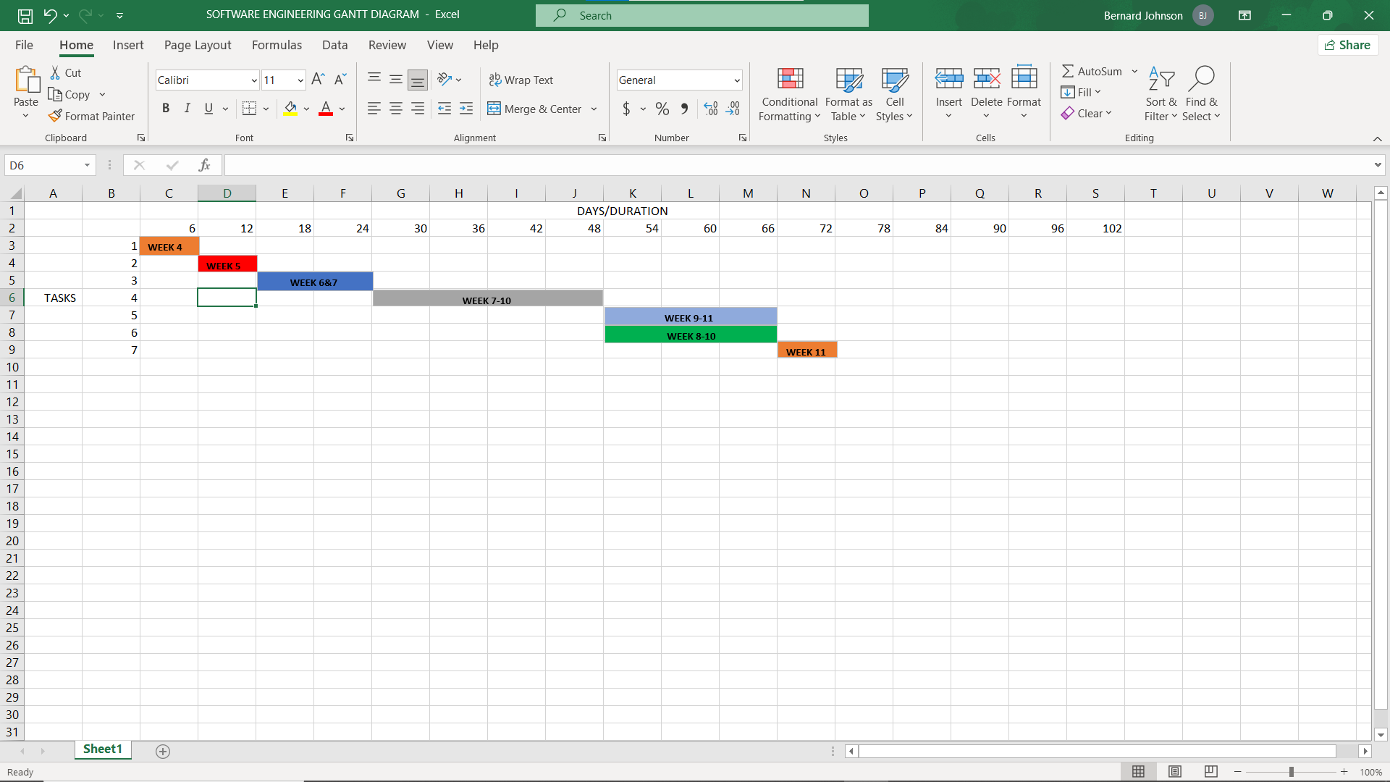

Network Diagram
The Network Diagram illustrates the dependencies between project tasks and identifies the Critical Path the longest sequence of dependent tasks that determines the minimum project duration.

Task Dependencies:

T1 (Planning) → T2 (Requirements)
T2 (Requirements) → T3 (Literature Review) → T4 (Architecture)
T4 (Architecture) → T5 (UML Diagrams) → T7 (Prototype 1–8)
T2 → T6 (GitHub Setup) → T7 (Prototype 1–8)
T7 → T8 (Prototype 9–15) → T9 (Testing) → T10 (Report) → T11 (Submission)

Critical Path: T1 → T2 → T4 → T5 → T7 → T8 → T9 → T10 → T11

Total Project Duration: 11 Weeks

Note: The actual Gantt Chart and Network Diagram visuals created using project management tools are included in Appendix C and in the GitHub repository under the /diagrams folder.

Results
This section presents the outcomes achieved through the design and development of the Career Guidance and Student Support Portal. It summarizes what was produced across each component of the project and evaluates the results against the original objectives defined in the introduction.
Outcomes Achieved
SDLC Documentation
The Agile Software Development Life Cycle was successfully applied to the project. All seven phases planning, Requirements Analysis, System Design, Prototype Development, Testing, Review and Iteration, and Deployment planning were completed and documented in detail. The sprint plan provided a structured timeline that kept the project on track throughout its eleven-week duration.
System Architecture
A comprehensive Three-Tier Client-Server Architecture was designed for the portal. The architecture clearly separates the presentation, application, and data layers, and integrates external services including Firebase Authentication, Cloud Storage, and Push Notifications. UML diagrams including a Use Case Diagram, Class Diagram, and two Activity Diagrams were produced to model the System’s structure and behavior.
Prototype Development
A total of fifteen high-fidelity screens were designed in Figma, exceeding the minimum requirement of ten screens. The prototype covers all major features of the application and demonstrates a complete and coherent user journey from registration through to career guidance and opportunity application.
GitHub Integration
A structured GitHub repository was created with clearly organized folders for documentation, prototype exports, diagrams, and assets. Commit with descriptive messages were used throughout the project track progress and demonstrate version control practices.
Project Management
A detailed Gantt chart and Network Diagram were produced, clearly mapping all eleven project tasks across the eleven-week timeline. The critical path was identified, demonstrating an understanding of task dependencies and project scheduling principles.
SDG Alignment
The system demonstrates clear and meaningful alignment with SDG 4: Quality Education, specifically targets 4.4 and 4.5. The platform’s features directly address the lack of career guidance, mentorship, and educational resources experienced by students in underserved African communities.

Discussion
Software License
The Career Guidance and Student Support Portal is released under the MIT License, one of the most widely used and permissive open-source software licenses available. The MIT License was chosen because it allows anyone to freely use, copy, modify, publish, distribute, and sublicense the software. It is compatible with the Digital Public Goods standard which requires open licensing, encourages collaboration and adoption by schools, NGOs, and government organizations across Africa, and is simple, widely understood, and legally recognized internationally. The full license text is included in Appendix A of this report.
Design Quality
The UI/UX design of the Career Guidance and Student Support Portal was developed with a strong emphasis on usability, visual consistency, and accessibility.
Visual Consistency: A unified design system was applied across all fifteen screens, with consistent use of the primary deep blue and secondary orange color palette, the Poppins font family, rounded card components, and outlined icons. This consistency creates a professional and trustworthy appearance that builds user confidence.
Usability: Navigation through the application follows familiar mobile patterns, including bottom navigation bars, card-based content layouts, and clear call-to-action buttons. These patterns reduce the learning curve for new users and ensure that students can find the features they need without confusion.
Accessibility: Font sizes were kept at a minimum of 14px for body text to ensure readability. High contrast color combinations were used throughout to support users with visual impairments. Button touch targets were sized generously to accommodate users of all ages and motor abilities.
User Experience: The overall user journey was carefully designed to be motivating and empowering. The progress tracker and achievement badges gamify the learning experience, encouraging continued engagement. The SDG Impact Dashboard gives students a sense of belonging to a larger community of learners working toward shared goals.

SDG Relevance and Real-World Impact
The Career Guidance and Student Support Portal is deeply aligned with SDG 4: Quality Education. The platform directly addresses two of the most significant barriers to quality education for African youth: lack of access to career guidance and scarcity of educational resources.
By providing free, mobile-accessible career assessments, personalized roadmaps, mentorship connections, and scholarship information, the portal empowers students who would otherwise navigate their futures without professional support. The SDG Impact Dashboard quantifies this impact by tracking the support. The SDG Impact Dashboard quantifies this impact by tracking the number of students reached , resources shared, and mentorship sessions facilitated.
Furthermore, the platform’s inclusivity being freely accessible, mobile-first, and available in areas with limited internet connectivity through offline resource downloading ensures that even the most underserved students can benefit from its features, directly supporting SDG 4’s commitment to leaving no one behind.

Conclusion
The Career Guidance and Student Support Portal represents a comprehensive, well-designed, and socially impactful Digital Public Good that addresses a critical gap in career education and student support across Africa. Through the application of the Agile Software Development Life Cycle, the project was systematically planned, designed, and documented across eleven weeks, resulting in a fully realized software design that includes a robust system architecture, detailed UML diagrams, a fifteen-screen high-fidelity Figma prototype, a structured GitHub repository, and a thorough project management plan.
The system’s alignment with SDG 4: Quality Education is clear and meaningful. By consolidating career assessment, mentorship, learning resources, and opportunity discovery into a single free mobile application, the portal has the potential to transform the educational and career trajectories of thousands of African students who currently lack access to these essential services.
The design decisions made throughout the project from the choice of the Agile methodology to the MIT open-source license and the mobile-first UI/UX approach reflect a deep understanding of both software engineering principles and the real-world context in which this system will operate. The Career Guidance and Student Support Portal is not merely an academic exercise; it is a viable and deployable solution to one of the most pressing developmental challenges facing African youth today

References
African Union Commission. (2016). Continental Education Strategy for Africa 2016–2025. Addis Ababa: African Union Commission.

Digital Public Goods Alliance. (2022). Digital Public Goods Standard Version 1.1.5. Retrieved from https://digitalpublicgoods.net/standard/

Eby, L. T., Allen, T. D., Evans, S. C., Ng, T., & DuBois, D. L. (2008). Does mentoring matter? A multidisciplinary meta-analysis comparing mentored and non-mentored individuals. Journal of Vocational Behavior, 72(2), 254–267.

GSMA. (2023). The Mobile Economy Sub-Saharan Africa 2023. London: GSMA Intelligence.

Holland, J. L. (1959). A theory of vocational choice. Journal of Counseling Psychology, 6(1), 35–45.

Hooley, T., Marriott, J., & Sampson, J. P. (2011). Fostering College and Career Readiness: How Career Development Activities in Schools Impact on Graduation Rates and Students’ Life Success. Derby: International Centre for Guidance Studies, University of Derby.

Super, D. E. (1980). A life-span, life-space approach to career development. Journal of Vocational Behavior, 16(3), 282–298.

United Nations. (2015). Transforming Our World: The 2030 Agenda for Sustainable Development. New York: United Nations.

United Nations Secretary-General. (2020). Roadmap for Digital Cooperation. New York: United Nations.
Appendices
Appendix A: MIT License
MIT License

Copyright (c) 2026 Career Guidance & Student Support Portal

Permission is hereby granted, free of charge, to any person obtaining a copy of this software and associated documentation files (the “Software”), to deal in the Software without restriction, including without limitation the rights to use, copy, modify, merge, publish, distribute, sublicense, and/or sell copies of the Software, and to permit persons to whom the Software is furnished to do so, subject to the following conditions:

The above copyright notice and this permission notice shall be included in all copies or substantial portions of the Software.

THE SOFTWARE IS PROVIDED “AS IS”, WITHOUT WARRANTY OF ANY KIND, EXPRESS OR IMPLIED, INCLUDING BUT NOT LIMITED TO THE WARRANTIES OF MERCHANTABILITY, FITNESS FOR A PARTICULAR PURPOSE AND NONINFRINGEMENT. IN NO EVENT SHALL THE AUTHORS OR COPYRIGHT HOLDERS BE LIABLE FOR ANY CLAIM, DAMAGES OR OTHER LIABILITY, WHETHER IN AN ACTION OF CONTRACT, TORT OR OTHERWISE, ARISING FROM, OUT OF OR IN CONNECTION WITH THE SOFTWARE OR THE USE OR OTHER DEALINGS IN THE SOFTWARE.

Appendix B: Glossary of Terms

Term | Definition
SDLC | Software Development Life Cycle a structured process for planning, creating, testing, and deploying software
Agile | An iterative software development methodology that emphasizes flexibility and continuous delivery
UML | Unified Modeling Language a standardized visual language for modeling software systems
API | Application Programming Interface a set of rules allowing different software systems to communicate
REST | Representational State Transfer an architectural style for designing networked applications
DPG | Digital Public Good open -source software, data, or content that contributes to the SDGs
SDG | Sustainable Development Goal a set of 17 global goals established by the United Nations for 2030
RIASEC | Holland’s model categorizing career personalities into sex types: Realistic, Investigative, Artistic, Social, Enterprising, Conventional
UI/UX | User Interface / User Experience the design of digital product interfaces and overall user experience
Figma | A web-based platform for version control and collaborative software development
Firebase | A cloud-based UI/UX design tool used for creating prototypes and interface designs
 | Google’s mobile and web application development platform providing backend services

Appendix C: List of Figures
Figure 1: System Architecture Diagram
Figure 2: Use Case Diagram
Figure 3: Class Diagram
Figure 4: Activity Diagram — Career Assessment Flow
Figure 5: Activity Diagram — Mentor Connection Flow
Figure 6: Gantt Chart
Figure 7: Network Diagram
Figure 8: Prototype Screen 1 — Splash Screen
Figure 9: Prototype Screen 2 — Onboarding Slides
Figure 10: Prototype Screen 3 — Registration Screen
Figure 11: Prototype Screen 4 — Login Screen
Figure 12: Prototype Screen 5 — Password Recovery Screen
Figure 13: Prototype Screen 6 — Career Assessment Screen
Figure 14: Prototype Screen 7 — Career Recommendations Screen
Figure 15: Prototype Screen 8 — Learning Resources Library Screen
Figure 16: Prototype Screen 9 — Mentor Browse Screen
Figure 17: Prototype Screen 10 — Mentor Chat Screen
Figure 18: Prototype Screen 11 — Scholarships & Opportunities Screen
Figure 19: Prototype Screen 12 — Student Profile Screen
Figure 20: Prototype Screen 13 — Progress Tracker Screen
Figure 21: Prototype Screen 14 — Notifications Screen
Figure 22: Prototype Screen 15 — SDG Impact Dashboard Screen
CLASS DIAGRAM / SYSTEM ARCHITECTURE
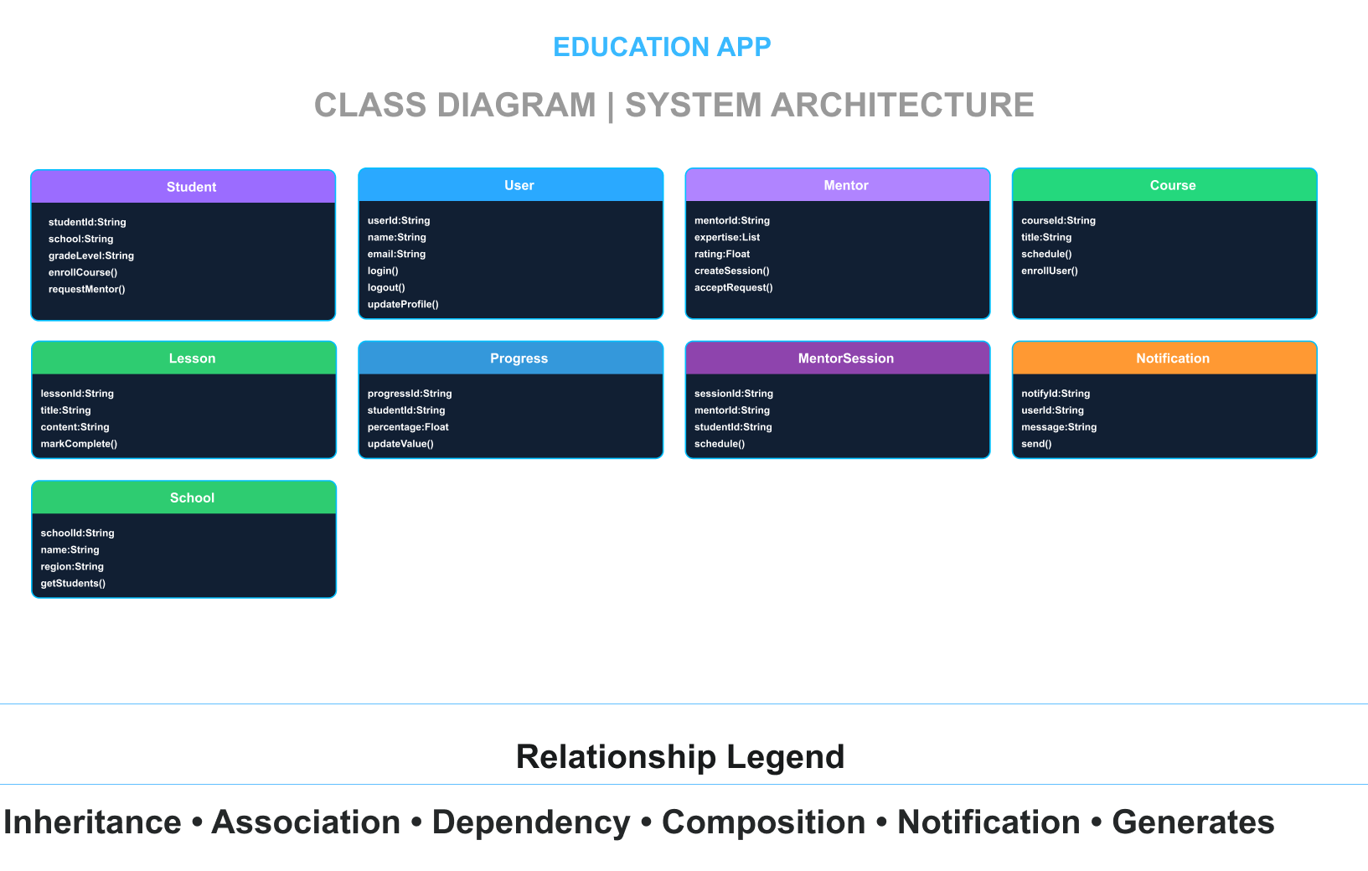

EDUCATION APP SYSTEM
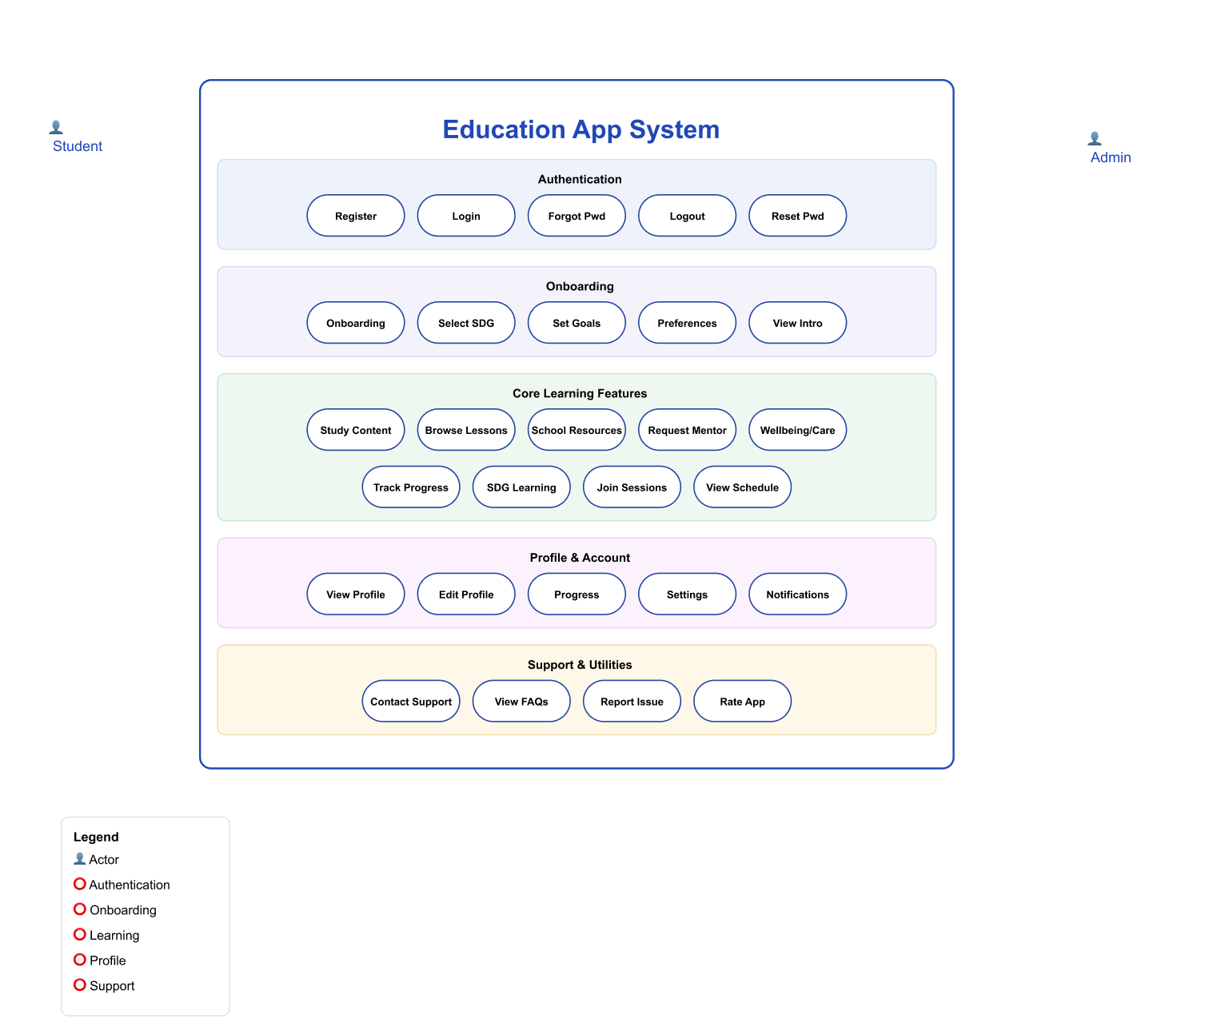

SCREEN ARCHITECTURE
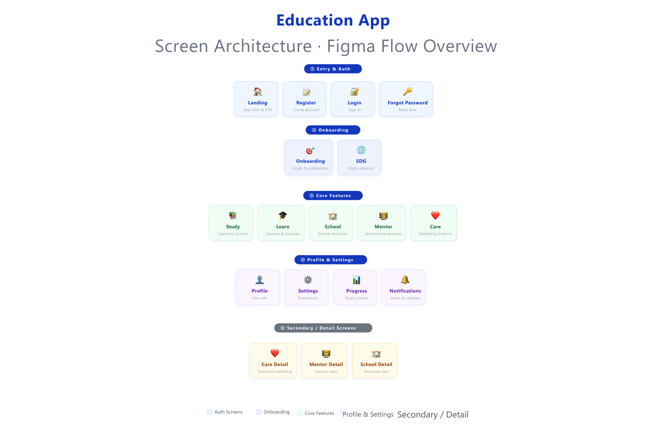

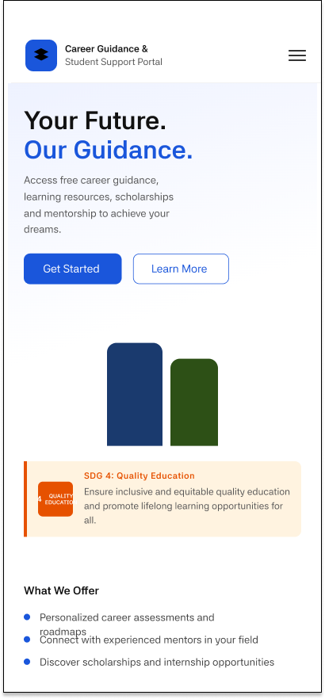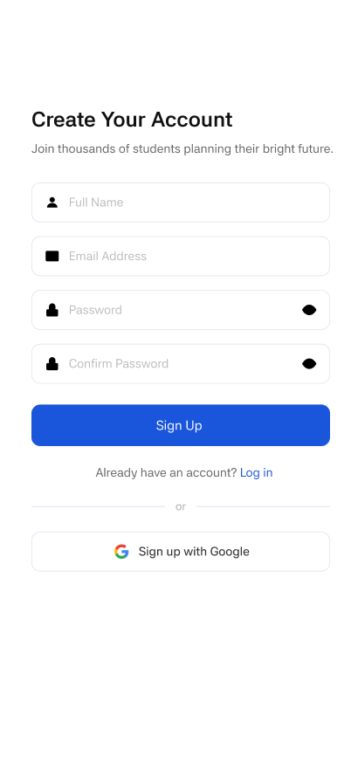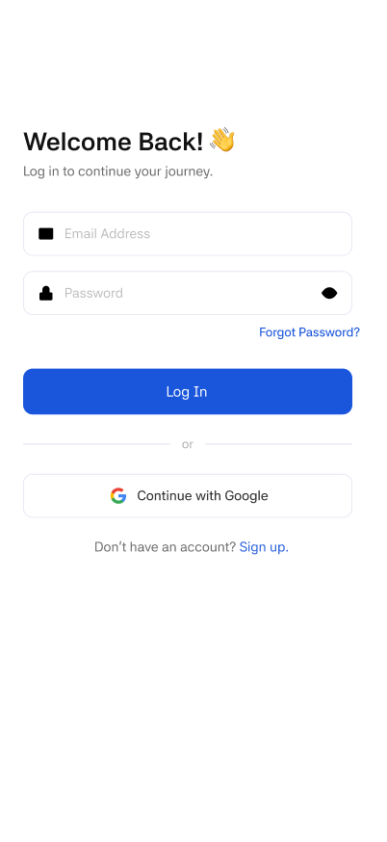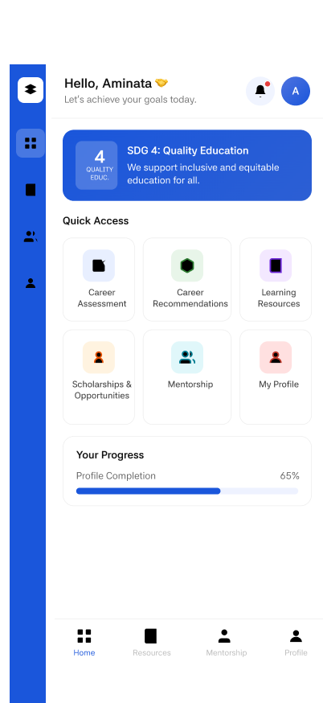
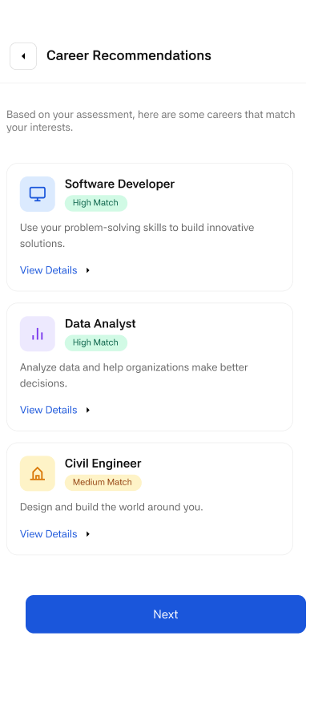
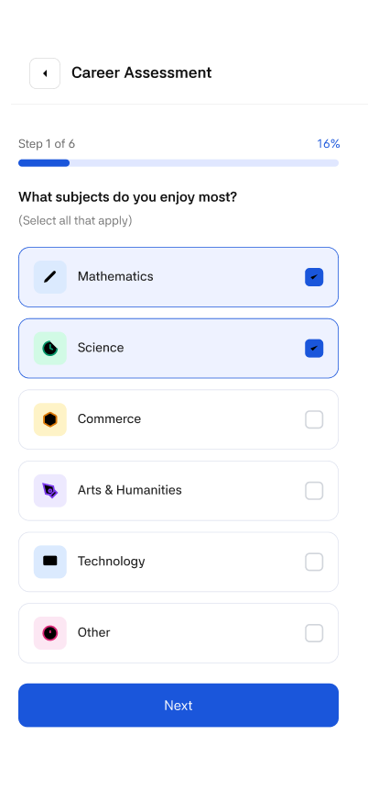
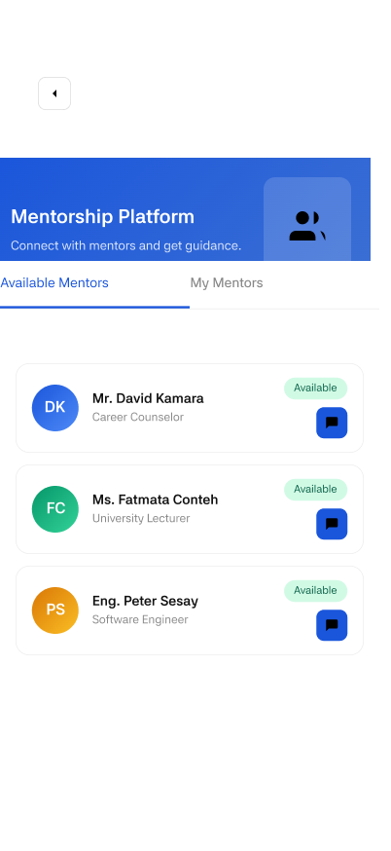
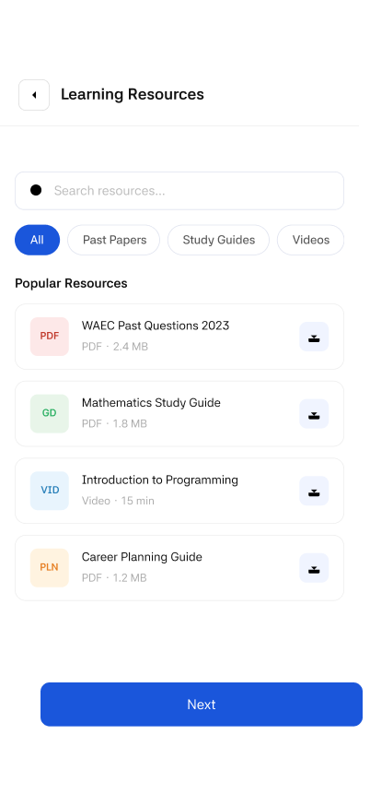

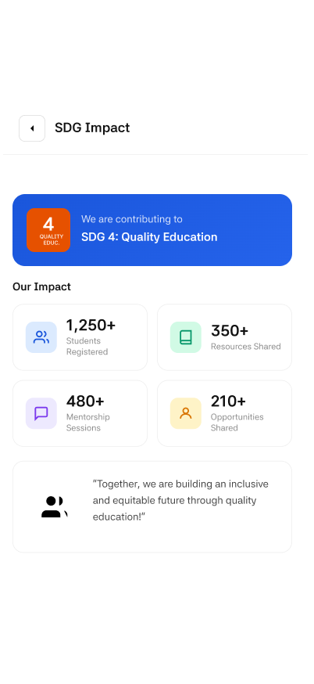
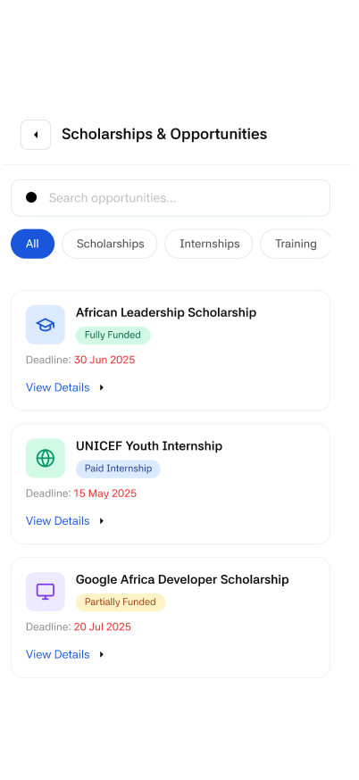

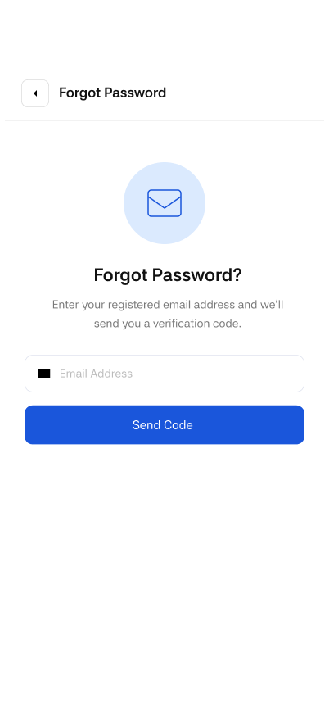
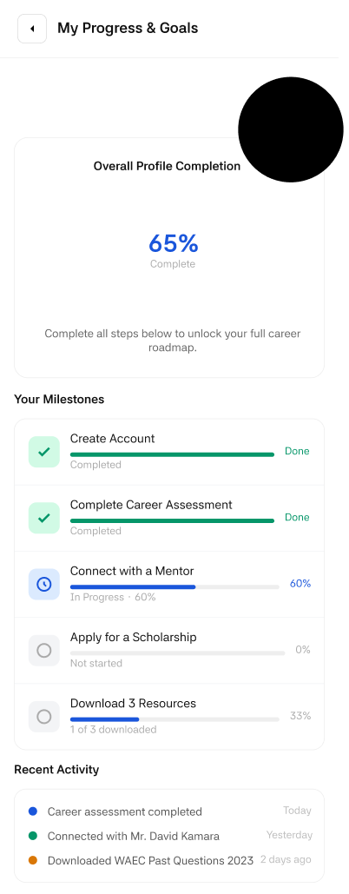

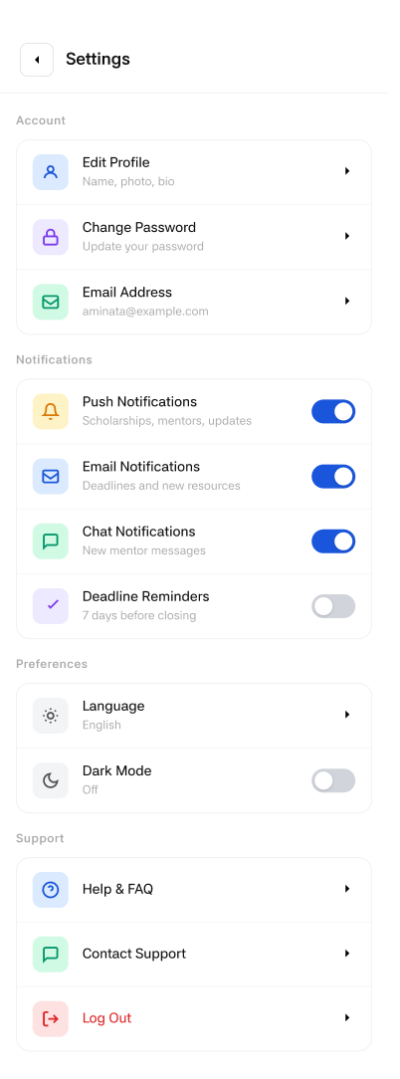
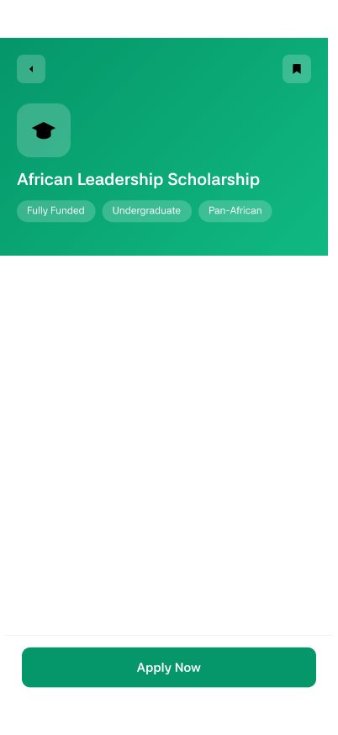
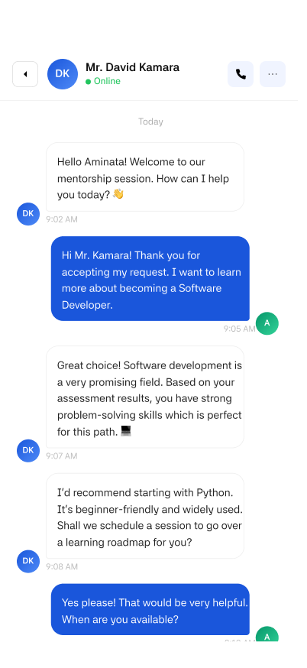
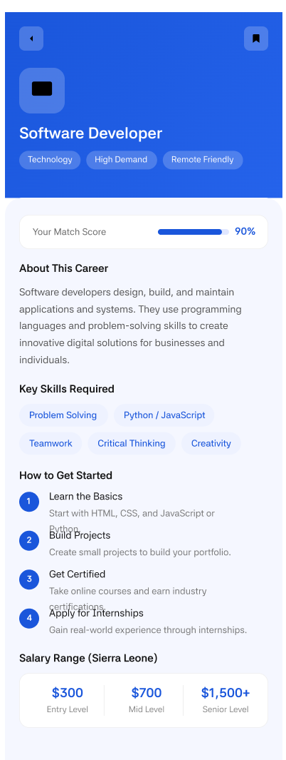
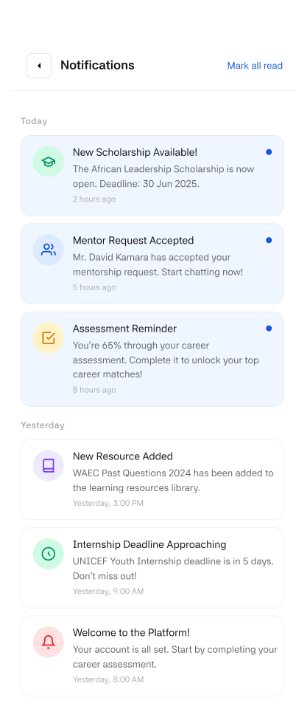
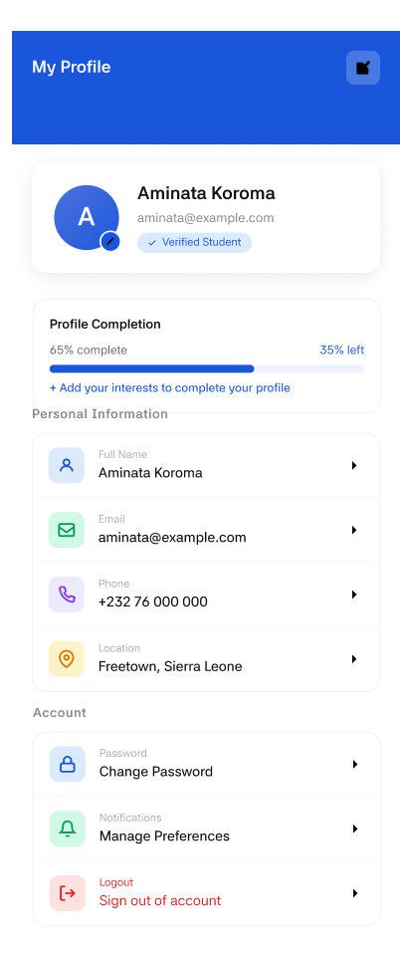

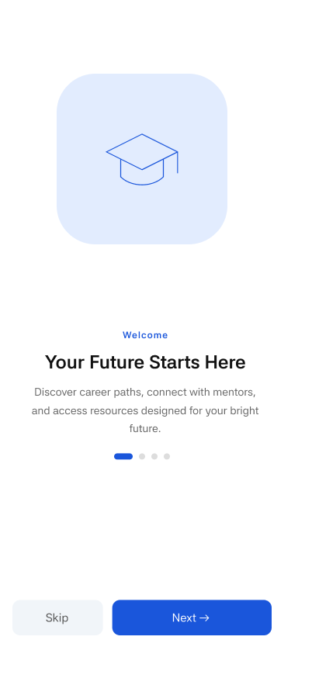
SCREEN NETWORK DIAGRAM

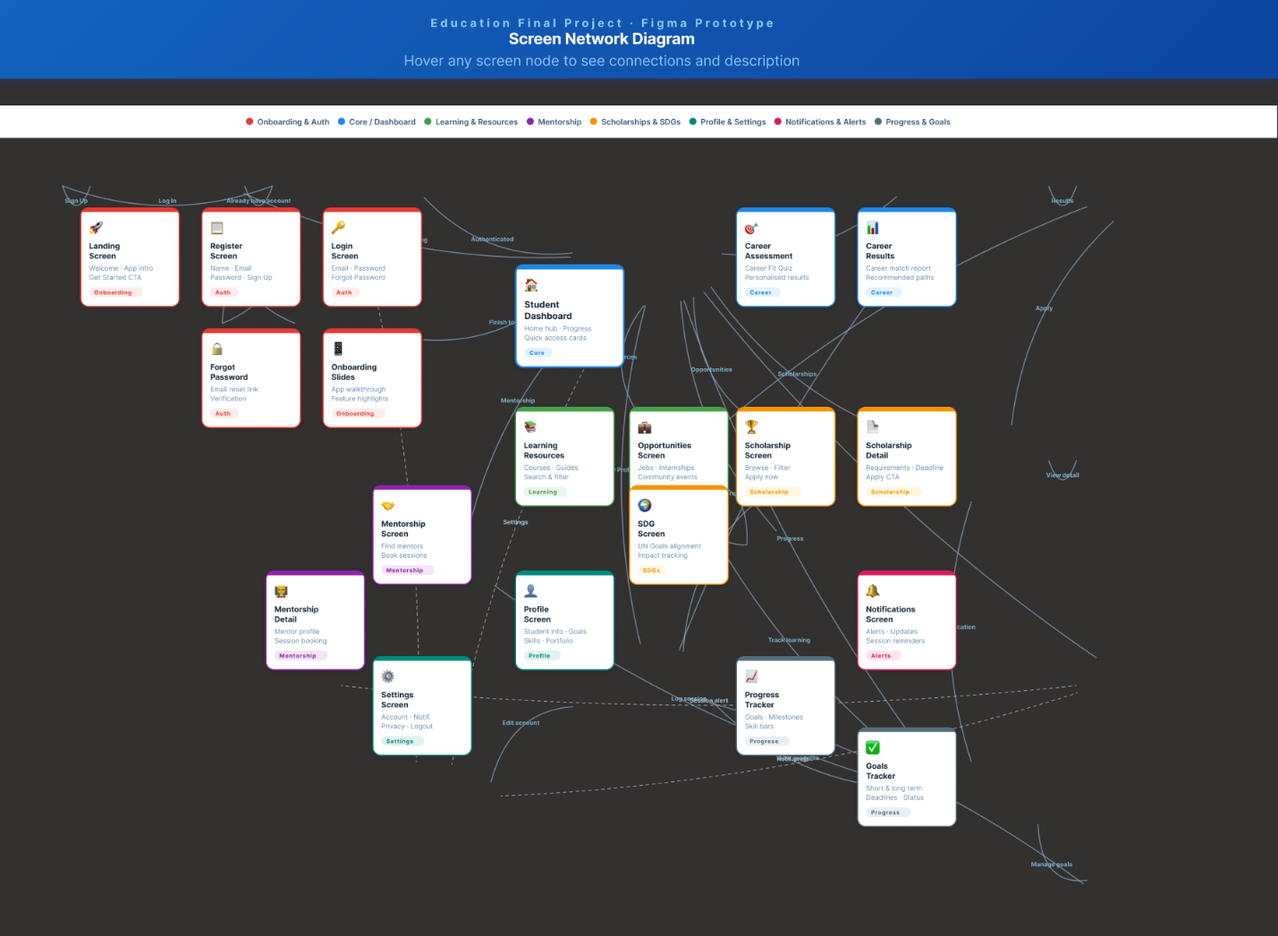
PROJECT PLAN
Student Career Guidance App
18 Screens · 4 Phases · 10-Week MVP Roadmap

App Summary
A mobile platform helping students with career discovery, mentorship, scholarships, and SDG-aligned opportunities. The application guides users from initial onboarding through personalized career assessment, resource discovery, mentor connection, and real-world impact tracking.

Screens Identified (18 Total)
Row 1 Primary Flows
- Landing Page
- Registration
- Login Screen
- Student Dashboard
- Career Assessment
- Career Recommendations
- Learning Resources
- Mentorship Platform
- Scholarships
- SDG Impact

Row 2 Secondary Flows
- Forgot Password
- Progress & Analytics
- Settings
- Scholarship Detail
- Mentor Chat
- Career Detail
- Notifications
- Profile Screen
- Onboarding Screen

Phase 1 Foundation & Auth
Weeks 1–2 Goal: Build the authentication and onboarding flow so users can create accounts and enter the app.

Screen | Owner | Weeks | Status
Onboarding Screen | Design | Week 1 | Planned
Landing Page | Design | Weeks 1–2 | Planned
Registration | Frontend | Weeks 1–2 | Planned
Login Screen | Frontend | Week 2 | Planned
Forgot Password | Frontend | Week 2 | Planned

Deliverable: User can sign up, log in, and recover their account.

Phase 2 Core Student Experience
Weeks 3–4 Goal: Deliver the dashboard and personalization engine so students see tailored career paths after completing the assessment.

Screen | Owner | Weeks | Status
Student Dashboard | Frontend | Weeks 3–4 | Planned
Career Assessment | All Teams | Weeks 3–4 | Planned
Career Recommendations | Backend | Week 4 | Planned
Progress & Analytics | Frontend | Week 4 | Planned

Deliverable: Students see personalised career paths after completing the assessment.

Phase 3 — Opportunities
Weeks 5–6 | Goal: Enable students to access learning resources, connect with mentors, and apply for scholarships.

Screen | Owner | Weeks | Status
Learning Resources | Frontend | Week 5 | Planned
Mentorship Platform | All Teams | Weeks 5–6 | Planned
Mentor Chat | Backend | Week 6 | Planned
Scholarships | Frontend | Weeks 5–6 | Planned
Scholarship Detail | Frontend | Week 6 | Planned

Deliverable: Students can browse resources, connect with mentors, and apply for scholarships.

Phase 4 Career & Impact
Weeks 7–10 Goal: Complete career tools, SDG tracking, profile management, and QA before launch.

Screen | Owner | Weeks | Status
Career Detail | Frontend | Week 7 | Planned
SDG Impact | All Teams | Weeks 7–8 | Planned
Notifications | Frontend | Week 8 | Planned
Profile Screen | Frontend | Week 8 | Planned
Settings | Frontend | Week 9 | Planned
Full QA Testing | QA | Weeks 9–10 | Planned
MVP Launch | All Teams | Week 10 | Planned

Deliverable: Fully functional app with profile management, notifications, and SDG impact tracking.

Team & Effort Estimate

Role | Responsibility | Est. Time
UI/UX Designer | All 18 screens, design system, prototyping | 3–4 weeks
Frontend Developer | Mobile implementation of all screens | 5–6 weeks
Backend Developer | Auth, AI career matching, real-time chat | 6–8 weeks
QA Engineer | Full end-to-end flow testing | 2 weeks

Total estimated timeline: 8–10 weeks for MVP.

Project Summary
Total screens: 18
Development phases: 4
MVP timeline: 10 weeks
Team roles: UI/UX Designer, Frontend Developer, Backend Developer, QA Engineer

